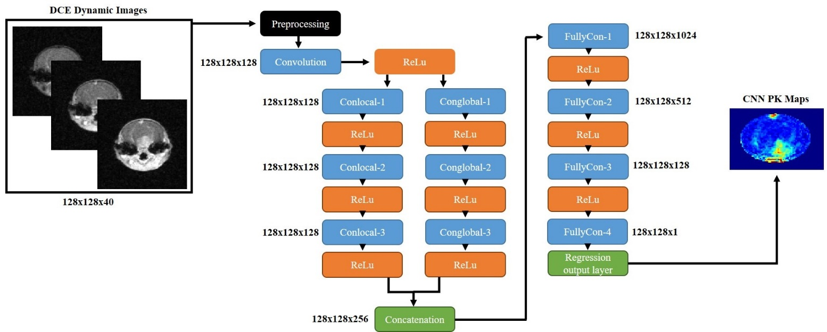
Supplementary Fig. 1. Twenty four-layer CNN. The CNN was designed with two parallel pathways, global and local, to capture low-level and high-level features in the DCE time series. All the convolutional layers are designed with 4 × 4 filters. DCE dynamic testing data can be fed into the pre-trained CNN to generate CNN PK maps.

Supplementary Table 1. Execution Time Profiles.
Modeling Step | Tofts Model [s] | Ex-Tofts Model [s] | CNN [s]
CA arrival identification | <60 | <60 | N/A
T1 map MRI acquisition¹ | 228 | 228 | N/A
T1 map generation | 3 | 3 | N/A
CA concentration map generation | 5 | 5 | N/A
PK parameter map generation | 15 | 245 | 2
¹Additional MRI acquisitions (T1 variable flip angle images) required for T1 mapping for conventional PK models.

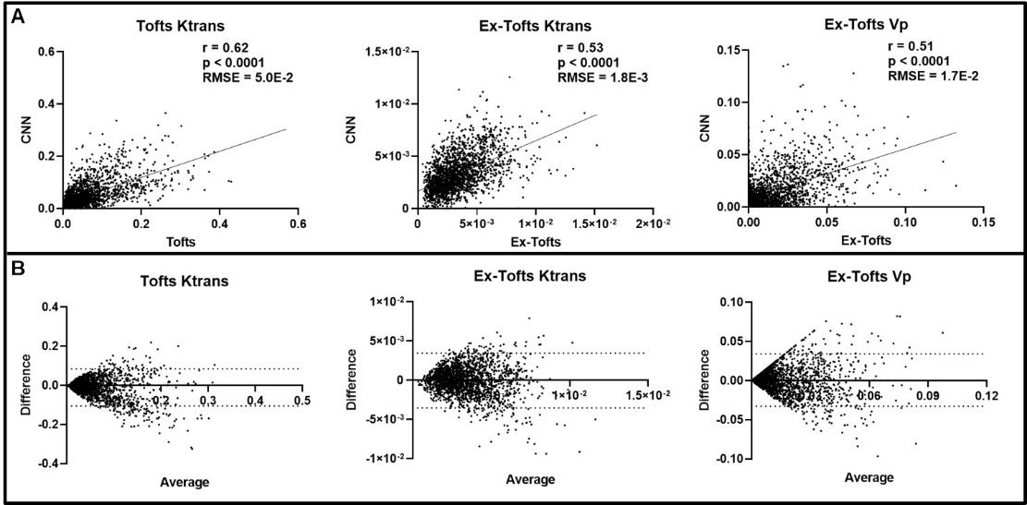
Supplementary Fig. 2. Intratumoral ensemble analysis of peripheral GBM tissue. (A) Pixel-by-pixel data (n = 2236) of tumor peripheral regions were plotted, revealing a significant linear correlation for Ktrans and Vp between CNN and target PK models (p < 0.0001). Low RMSEs were found between the target PK models and the CNN for all three parameters (RMSE < Target PK parameter SD). (B) Bland-Altman plots of PK parameters were generated with dashed lines corresponding to the upper and lower 95% confidence intervals.

